ONLINE RESOURCE S2
Stochastic Avoidance and Outbreak Probability Analysis

Structural Barriers, Stochastic Avoidance, and Outbreak Risk in HIV Prevention for PWID
AC Demidont, DO — Nyx Dynamics LLC
Contents
S2.1 Stochastic Avoidance Conceptual Framework
S2.2 Network Density Model
S2.3 Outbreak Probability Calculation
S2.4 Model Parameters
S2.5 National Outbreak Forecast
S2.6 Regional Heterogeneity
S2.7 Tornado Analysis
S2.8 Policy Scenarios
S2.9 Supplementary Figures
S2.10 References

S2.1 Stochastic Avoidance Conceptual Framework
The stochastic avoidance model quantifies the probability that HIV outbreaks among PWID are avoided through probabilistic non-transmission rather than active intervention. This framework captures the hypothesis that current "prevention" relies on network density remaining below critical thresholds rather than pharmaceutical interventions achieving sustained R⁰=0.
Stochastic avoidance is defined as prevention arising from instances where exposure events did not result in infection despite absence of effective prevention. As network density and exposure frequency increase, the cumulative probability of transmission approaches one, making stochastic avoidance increasingly unstable.
S2.2 Network Density Model
Effective network density ρ(t) was modeled as:
ρ(t) = ρ₀ + M × C(t) + 0.5 × H
Where ρ₀ = baseline density (0.15), C(t) = contextual driver, M = network expansion multiplier (2.5), H = housing instability (0.685). The contextual driver C(t) represents exogenous structural factors affecting network connectivity, parameterized using observed trends in stimulant-associated network expansion from outbreak investigations; it is treated as a contextual modifier rather than an individual-level behavioral determinant.
S2.3 Outbreak Probability Calculation
P_outbreak(ρ) = P₀ × exp(3 × max(0, ρ - ρ_crit)) × (1 - SSP × 0.4) × (1 - OAT × 0.3)
Where P₀ = 0.03, ρ_crit = 0.35, SSP = 0.21, OAT = 0.08. For each simulation (n=2,000), we iterate annually, calculating density and outbreak probability until outbreak occurs or 20-year horizon.

S2.4 Model Parameters
Table S2.1. Stochastic Avoidance Model Parameters
Parameter | Value | Range | Source
Baseline network density (ρ₀) | 0.15 | 0.08–0.25 | Model calibration
Contextual driver baseline | 0.143 | — | [16]
Contextual driver growth | 2.5%/yr | 1–5% | [16,17]
Network expansion multiplier | 2.5 | 1.5–4.0 | [9,10]
Critical threshold (ρ_crit) | 0.35 | 0.25–0.45 | [10]
Baseline outbreak prob (P₀) | 0.03 | 0.01–0.08 | [17,18]
Housing instability | 0.685 | 0.55–0.80 | [15]
SSP coverage | 0.21 | 0.15–0.30 | [14]
OAT coverage | 0.08 | 0.04–0.15 | [9]
Incarceration rate | 0.30/yr | 0.20–0.45 | [3,4]

S2.5 National Outbreak Forecast
Table S2.2. National Forecast (n=2,000)
Metric | Value
Total simulations | 2,000
Outbreaks | 1,943 (97.2%)
Median years | 3.0
Mean years | 3.79 (SD 3.71)
P(5-year) | 73.8%
P(10-year) | 92.7%
S2.6 Regional Heterogeneity
Table S2.3. Regional Comparison (n=1,000 each)
Region | Rate | Median | P(5-yr) | P(10-yr)
Pacific Northwest | 99.6% | 2.0 | 86.3% | 98.0%
Appalachia | 97.6% | 2.0 | 78.4% | 94.9%
Northeast Urban | 98.8% | 2.0 | 78.3% | 94.2%
National Average | 97.1% | 3.0 | 72.5% | 92.7%

S2.7 Tornado Analysis
Table S2.4. Sensitivity of 5-Year Outbreak Probability
Parameter | Low | High | Range
Network expansion multiplier | 69.4% | 77.5% | 8.2%
Incarceration rate | 69.3% | 77.4% | 8.1%
SSP coverage | 74.8% | 67.7% | 7.1%
Baseline density | 69.3% | 75.9% | 6.6%
Contextual driver growth | 69.3% | 73.8% | 4.5%
Baseline outbreak prob | 67.8% | 71.8% | 4.0%
Housing instability | 70.2% | 68.9% | 1.3%
OAT coverage | 70.7% | 71.1% | 0.4%
Critical threshold | 73.0% | 73.1% | 0.04%
S2.8 Policy Scenarios
Table S2.5. Policy Scenario Comparison
Scenario | SSP | OAT | Rate | Median | P(5-yr)
Current Policy | 21% | 8% | 97.5% | 3.0 | 69.5%
SSP Expansion | 50% | 8% | 95.8% | 3.0 | 67.6%
OAT Expansion | 21% | 40% | 96.1% | 3.0 | 70.0%
Combined | 50% | 40% | 92.9% | 4.0 | 61.9%
Decriminalization* | 40% | 30% | 92.0% | 4.0 | 64.3%
Full HR* | 80% | 60% | 78.9% | 5.0 | 50.8%
*Includes reduced incarceration (10%/5%) and housing instability (50%/30%)

S2.9 Supplementary Figures
Fig. S1 Contextual stochastic failure driver. Projected trajectories of an exogenous network-density modifier used to parameterize stochastic avoidance and outbreak probability models. The driver is treated as a contextual structural factor influencing network connectivity rather than an individual-level behavioral determinant. Trajectories show national average (solid line) and regional profiles (Appalachia, Pacific Northwest, Northeast Urban) with 2.5% annual growth from varying baselines. Shaded regions indicate parameter uncertainty ranges used in sensitivity analyses

Fig. S2 National outbreak forecast. (a) Cumulative outbreak probability over time, reaching 73.8% at 5 years and 92.7% at 10 years under current policy conditions. (b) Distribution of time-to-outbreak across n=2,000 simulations showing median of 3.0 years (interquartile range 1–6 years). Vertical dashed lines indicate 5-year and 10-year horizons

Fig. S3 Tornado diagram. Sensitivity of 5-year outbreak probability to parameter variation. Horizontal bars indicate change in P(5-year outbreak) when each parameter is varied from lower to upper bound while holding others at baseline. Network expansion multiplier (8.2% range) and annual incarceration rate (8.1% range) show greatest influence; critical network threshold shows minimal sensitivity (0.04% range). Parameters ordered by magnitude of influence

Fig. S4 Policy scenario comparison. Five-year outbreak probability across policy interventions from Current Policy (69.5%) to Full Harm Reduction (50.8%). Scenarios include: Current Policy (21% SSP, 8% OAT); SSP Expansion (50% SSP); OAT Expansion (40% OAT); Combined SSP+OAT; Decriminalization (reduced incarceration to 10%, housing instability to 50%); Full Harm Reduction (80% SSP, 60% OAT, 5% incarceration, 30% housing instability). Error bars indicate 95% confidence intervals from n=1,000 simulations per scenario

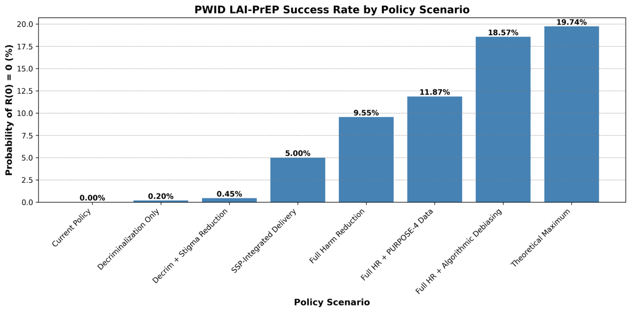
Fig. S5 Policy scenario detail: cascade success rates. Probability of achieving sustained HIV prevention P(R⁰=0) across policy scenarios for PWID. Values range from 0.003% (Current Policy) to 19.74% (Theoretical Maximum). SSP-Integrated Delivery achieves 5.00%, Full Harm Reduction achieves 9.55%, and Full HR + Algorithmic Debiasing achieves 18.57%, exceeding the MSM reference rate of 16.3%

Code Availability
All code: https://github.com/Nyx-Dynamics/HIV_Prevention_PWID
Key files: stochastic_avoidance_enhanced.py, config/parameters.json
S2.10 References
References are numbered continuously with the main text. Key references for Online Resource S2:
[3] DeBeck K, et al. HIV and the criminalisation of drug use among people who inject drugs: a systematic review. Lancet HIV. 2017;4(8):e357–e374. https://doi.org/10.1016/S2352-3018(17)30073-5
[4] Stone J, et al. Incarceration history and risk of HIV and hepatitis C virus acquisition among people who inject drugs. Lancet Infect Dis. 2018;18(12):1397–1409. https://doi.org/10.1016/S1473-3099(18)30469-9
[9] Strathdee SA, et al. Preventing HIV outbreaks among people who inject drugs in the United States. AIDS. 2020;34(14):1997–2005. https://doi.org/10.1097/QAD.0000000000002673
[10] Des Jarlais DC, et al. Potential disruptions of HIV prevention among people who inject drugs in NYC from the COVID-19 pandemic. Drug Alcohol Depend. 2022;227:109505. https://doi.org/10.1016/j.drugalcdep.2022.109505
[14] Van Handel MM, et al. County-level vulnerability assessment for rapid dissemination of HIV or HCV infections among persons who inject drugs. J Acquir Immune Defic Syndr. 2016;73(3):323–331. https://doi.org/10.1097/QAI.0000000000001098
[15] Arum C, et al. Homelessness, unstable housing, and HIV and hepatitis C virus acquisition risk among people who inject drugs. Lancet Public Health. 2021;6(5):e309–e323. https://doi.org/10.1016/S2468-2667(21)00013-X
[16] Glick SN, et al. Increasing methamphetamine injection among non-MSM who inject drugs in King County, Washington. Drug Alcohol Depend. 2018;182:86–92. https://doi.org/10.1016/j.drugalcdep.2017.10.011
[17] Alpren C, et al. Opioid use fueling HIV transmission: an outbreak of HIV infection among people who inject drugs—Massachusetts. Am J Public Health. 2020;110(1):37–44. https://doi.org/10.2105/AJPH.2019.305366
[18] Bonacci RA, et al. Prevention and care opportunities for people who inject drugs in an HIV outbreak—Kanawha County, West Virginia. J Gen Intern Med. 2023;38(3):828–831. https://doi.org/10.1007/s11606-022-07875-w

